格式范本
Title for MANDARINABLE: Journal of Chinese Studies (English)
(Align Left, SimSun 16 Pt, maximum 20 words)
| Author name1^{1,*} | Author name2² | Author name3³ |
¹Department, University or Company name
²Department, University or Company name
³Department, University or Company name
name_email@mail.com
ABSTRACT (only English)
The abstract should be descriptive, and self-explanatory. The abstract without abbreviations, footnotes, or references. The structure of the abstract should mirror the structure of the whole paper. For example, if your paper has four sections (introduction, method, results and discussion, and conclusion), there should be one or more sentences assigned to summarize each section. In details, abstract should include: 1) the overall purpose of the study and the research problem(s) you investigated; 2) the basic design of the study; 3) major findings or trends found as a result of your analysis; and, 4) a brief summary of your interpretations and conclusions. The abstract should not exceed 250 words.
KEYWORDS
Keyword1; Keyword2; Keyword3; Keyword4; Keyword5.

INTRODUCTION （引言）
The introduction contains (in sequence) a general background, a state of the art review, a statement of scientific novelty, and the problems. It should explain the importance of the research and of the results being reported, as well as any relevance they have to other prior studies. At the end of the introduction should be written the purpose of the article. For scientific purposes, there is no bibliographical that must be written here. It is manifested in the form of a state of the art to show the scientific novelty of the study. （中文：宋体；12pt）

RESEARCH METHODS （研究方法）
The research methods can be written as independent sub-chapters if the article becomes the research result. This section should be written as concisely as possible but should contain all elements necessary to allow interpretation and replication of the results. This section is expected to expose sources that have been used. In the meantime, the method also can be included in the introduction section if the article written using literature studies or reflective works.

RESULTS AND DISCUSSION （研究结果及探讨）
In this section, the results of the analysis are presented, but not discuss their significance. How the results are presented will depend upon whether the research study was quantitative or qualitative in nature. This section should focus only on results that are directly related to the research or the problem. Graphs and tables should only be used when there is too much data to efficiently include it within the text.
This section also should be a discussion of the results and the implications on the field, as well as other fields. The hypothesis should be answered and validated by the interpretation of the results. This section should also discuss how the results relate to previous research mentioned in the literature review, any cautions about the findings, and potential for future research. The results and discussion section are often combined into one section because readers can seldom make sense of results alone without accompanying interpretation.
Figure

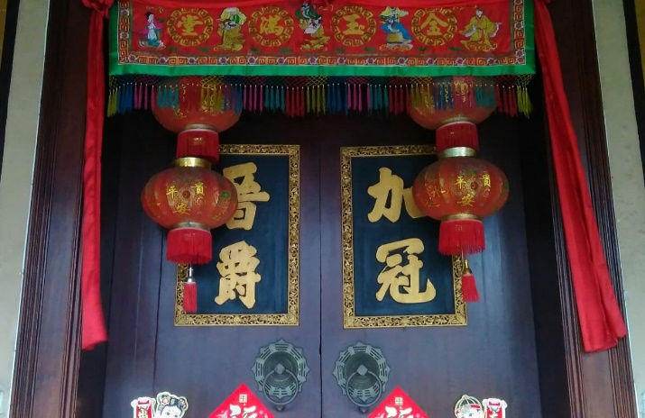
Figure 1. Title of figure, 2022
Gambar 1. xxxx /图1.…
Table
Table 1. Title of table
Tabel 1 xxxxx/表 1.......

Font Size | Font Formatting
Font Size | Regular | Bold | Italic
12 | Title table, title figure, content of table, reference item
12 | Abstract | Paper of title, author name, heading of abstract, heading of keyword | Affiliation address, keyword

Equations
Equations should be placed at the center of the line and provided consecutively with equation numbers in parentheses flushed to the right margin, as in (1). You must use Microsoft Equation Editor. The normal size of variables within the equation should be 10 pt,
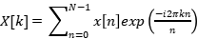 (1)
where N is number of input samples, is the k^{th} harmonic (k = 0,1, ..., N-1), and x[n] is the n^{th} input sample (n = 0,1, ..., N-1)
CONCLUSION （结论）
The conclusion illustrates the problem that has been formulated. The conclusion is not repetitive, but rather on the summary of the findings of the problems. Sometimes, the author also points out any limitations, and offer suggestions for future research.

ACKNOWLEDGMENT
All acknowledgments (if any) should be included at the very end of the paper before the references. This section is the place to acknowledge people (dedications), places, and financing (you may state grants and sponsors here).

REFERENCES （参考文献）
[1] Adi, D. P., & Rinada, A. (2020). The Role of Mandarin in Indonesia's Tourism Sector. International Journal of Cultural and Art Studies, 4(1), 24-30.
[2] Elvaretta, E., & Herman, H. (2021). 印尼华语语气词 [méh] 调查研究 Analisis Kata Partikel Modal [méh] dalam Bahasa Tionghoa Indonesia. Jurnal Cakrawala Mandarin, 5(1), 75-95.
[3] Kusumaningtyas, D. P. S. (2020, December). A Comparative Analysis Pragmatics of Social Deixis in Chinese and Indonesian. In Talenta Conference Series: Local Wisdom, Social, and Arts (LWSA) (Vol. 3, No. 4, pp. 26-30).
[4] Meng, L. Y., Cheng-Chwee, K., & Abdullah, A. A. (2021). Pulau Layang-Layang in Malaysia's South China Sea Policy: Sovereignty Meets Geopolitical Reality amid China-US Rivalry. International Journal of China Studies, 12(2), 189-222.
[5] Mursitama, T. N., & Ying, Y. (2021). Indonesia’s perception and strategy toward China’s OBOR Expansion: hedging with balancing. The Chinese Economy, 54(1), 35-47.
[6] Phanata, S., M., & Suci, I. R. (2022). Efektivitas Metode Mind Mapping dalam Pembelajaran Bahasa Mandarin bagi Siswa Sekolah Menengah Pertama. Jurnal Cakrawala Mandarin, 5(2), 130-137.
[7] Rudiansyah, R. (2021). Tipologi Arsitektur Bangunan Pecinan di Kesawan Medan. Berkala Arkeologi Sangkhakala, 24(2), 135-146.
[8] Sutami, H. (2016). Fungsi dan Kedudukan Bahasa Mandarin di Indonesia. Paradigma: Jurnal Kajian Budaya, 2(2), 212-239.
[9] Wuryandari, N. W. (2013). Study on the documents of Java in Siku Quanshu; Historical knowledge and historians’ point of view. Wacana, 15(1), 189-199.
[10] Yu, LU (2022). Analysis of" Harmony" and" Unity" Concepts in Indonesian and Chinese Culture. MANDARINABLE: Journal of Chinese Studies, 1(1), 10-16.
[11] Yue, W. A. N. G. (2022). 中国动画电影海外跨文化传播困境与新媒体环境下跨文化传播策略探析——以《 哪吒之魔童降世》 为例. MANDARINABLE: Journal of Chinese Studies, 1(1), 30-36.
[12] Ying, Y., Mursitama, T. N., & Novianti, N. (2018). Suitability of Textbook for the Improvement of Linguistic Competence in Chinese by International Relations Students in Indonesia. Pertanika Journal of Social Sciences & Humanities, 26(3).

